**Supplementary Material**

Alexander G. Kozlov, Xian Cheng, Hongshan Zhang, Min Kyung Shinn, Elizabeth Weiland, Binh Nguyen, Irina A. Shkel, Emily Zytkiewicz, Ilya J. Finkelstein, M. Thomas Record, Jr. and Timothy M. Lohman

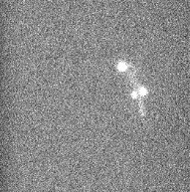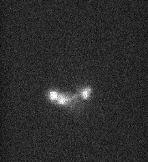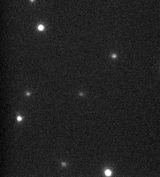

5 µM SSB

Fiber formation

droplets

**Figure S1. Microscopic observations support formation of liquid phase droplets in the range of linear increase of turbidity and formation of solid phase at the maximum of turbidity curve.**

Change in turbidity (OD at 600 nm) of a wtSSB protein solution (5 µM) (buffer T, 0.20 M KGlu) measured upon decreasing temperature from 35oC to 3oC and reflecting formation liquid-liquid phase at temperatures below TPS=30.1oC. Superimposed with the turbidity curve are microscopic images of a 5 µM SSB solution containing 20 nM of SSB labeled with Cy5 (buffer T, 0.20 M KGlu ) at 27.5oC and 22.5oC using TIRF confocal microscope (see Materials and Methods) and reflecting appearance of liquid droplets in the linear part of turbidity curve and fibril like structures at the maximum of turbidity change, respectively.

(i)



4 µM SSB

A

SSB:dT35/70 =1:1

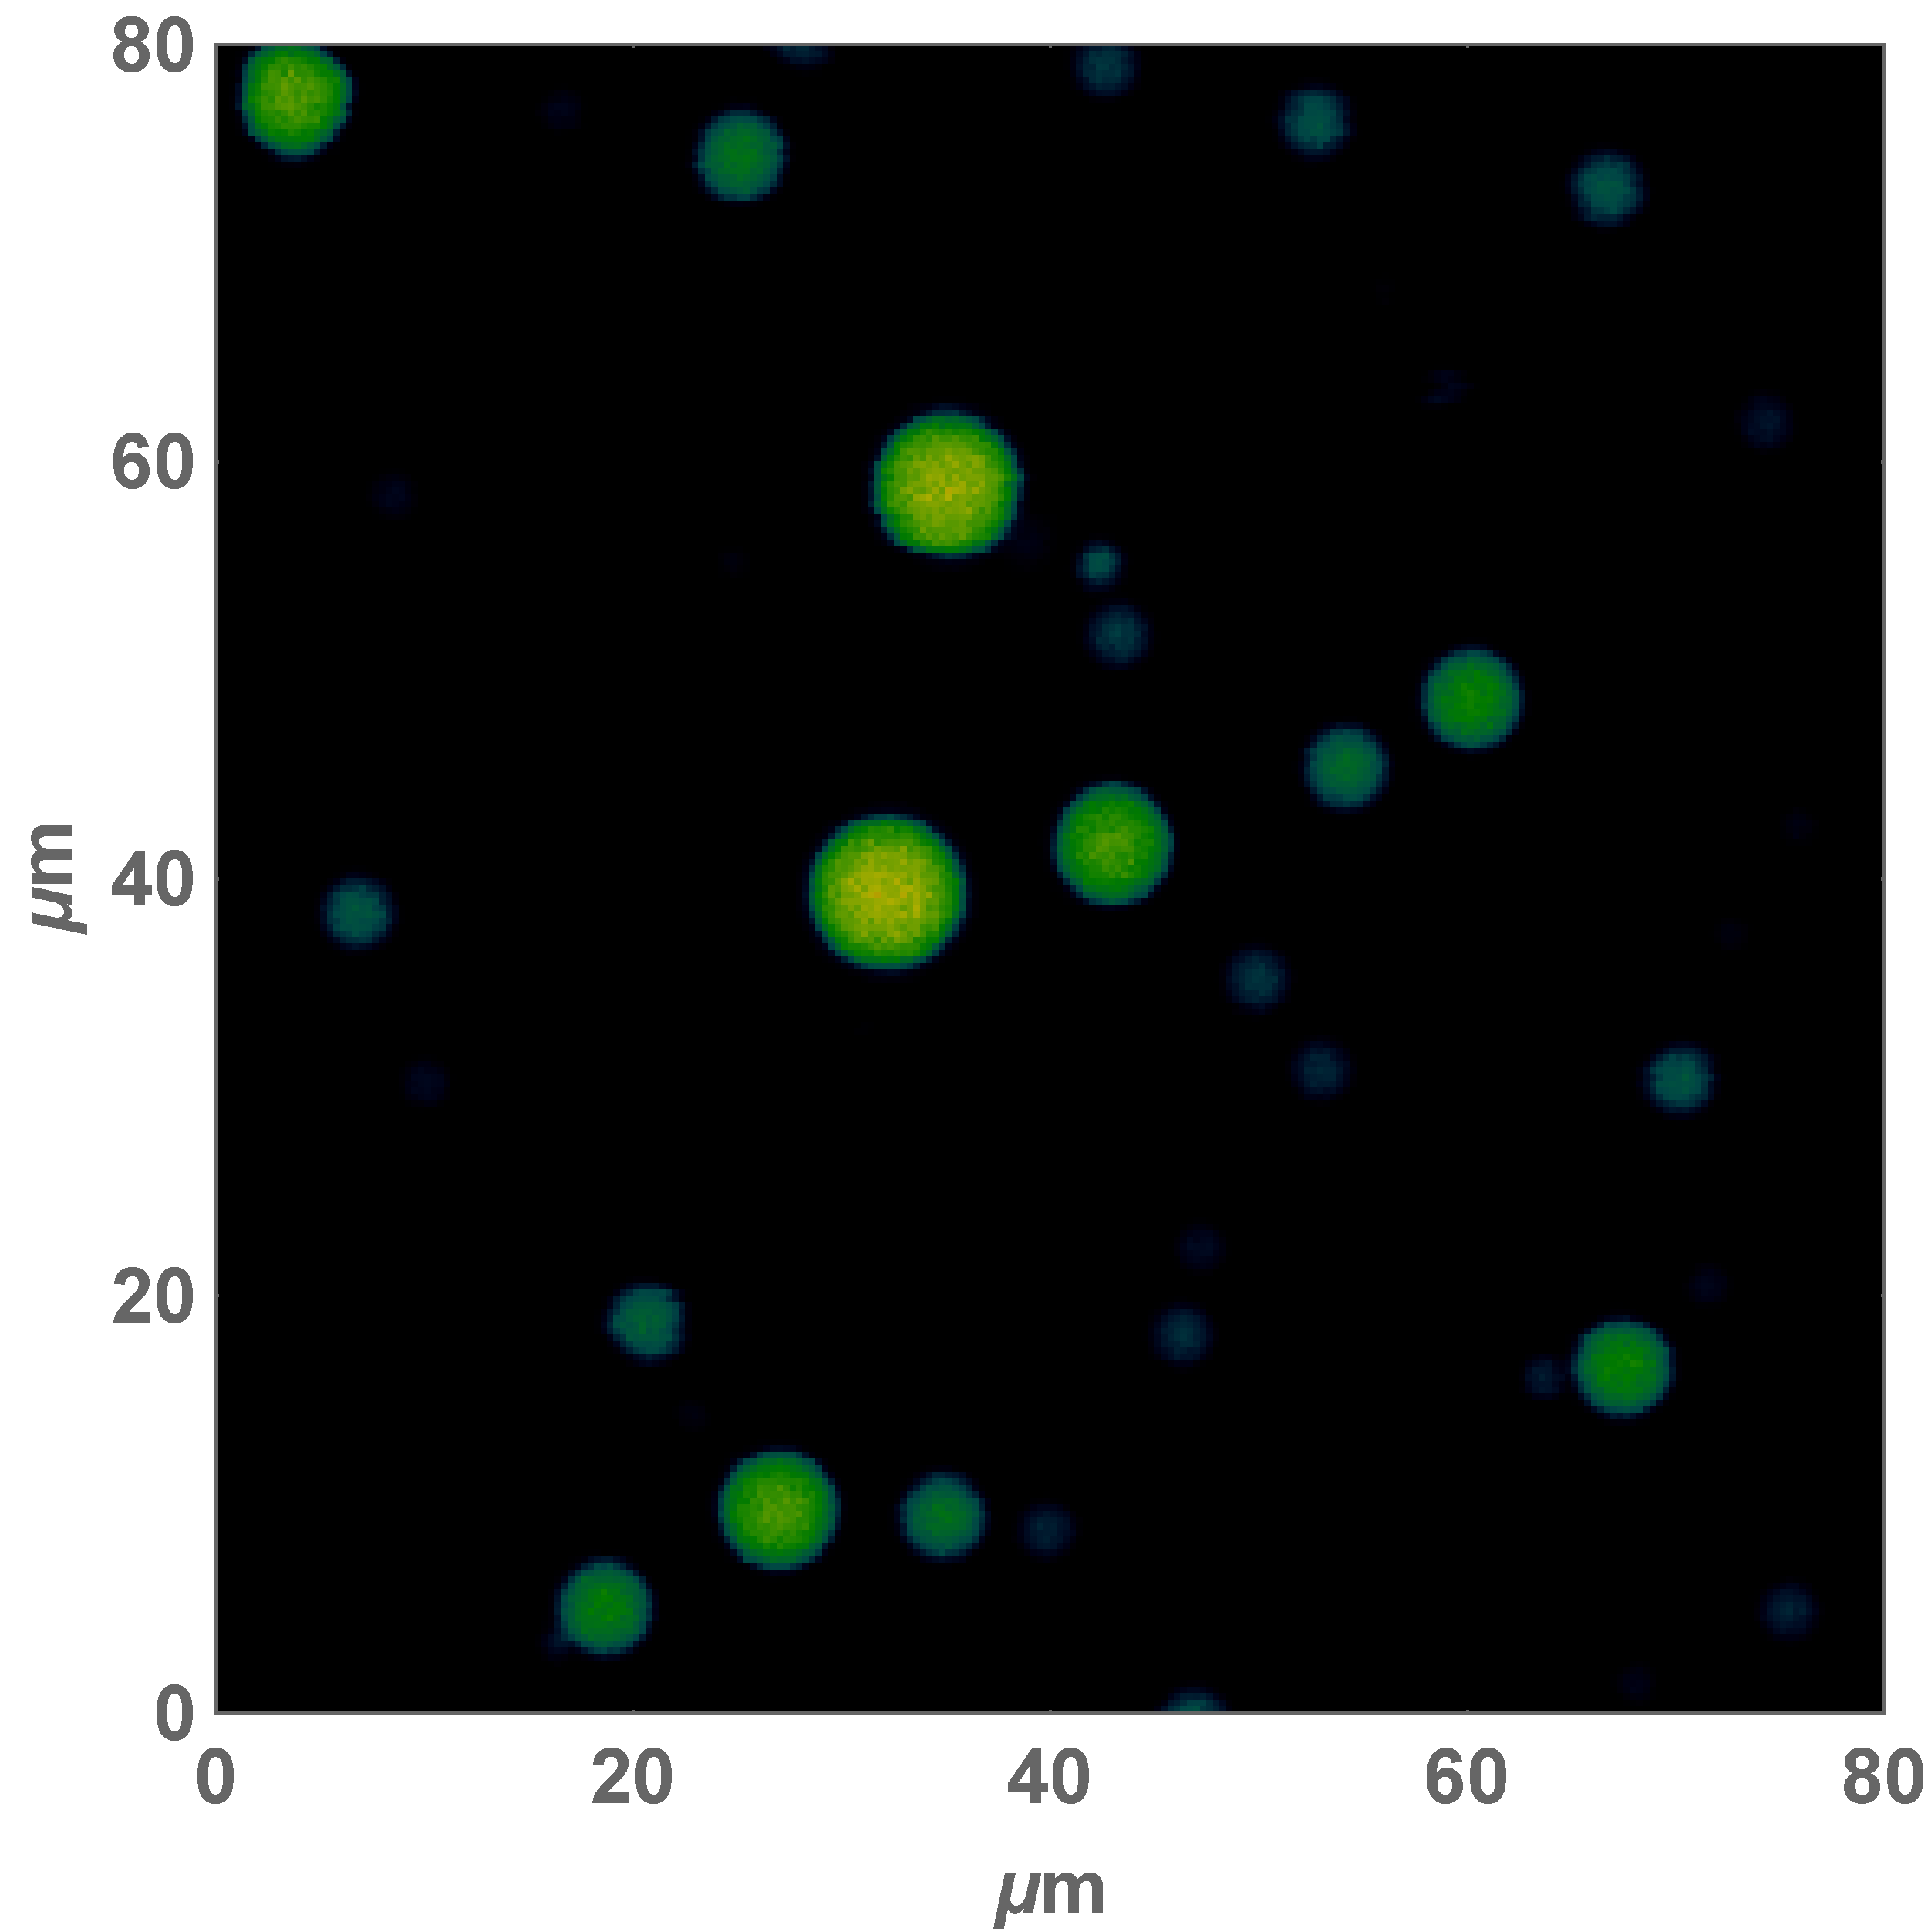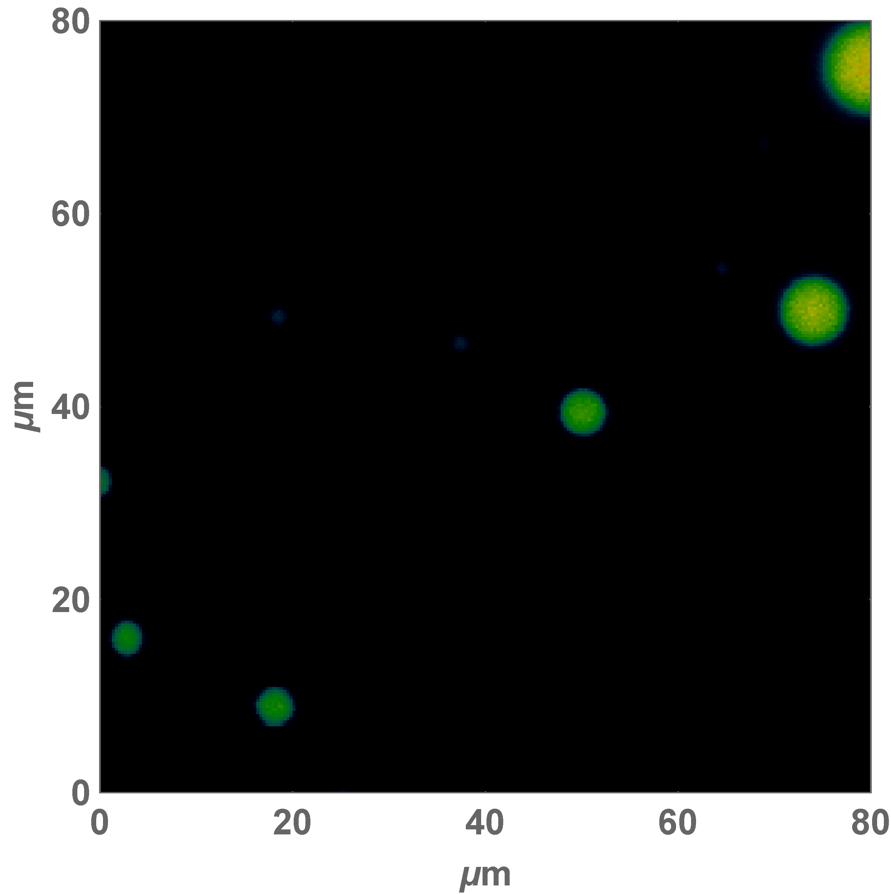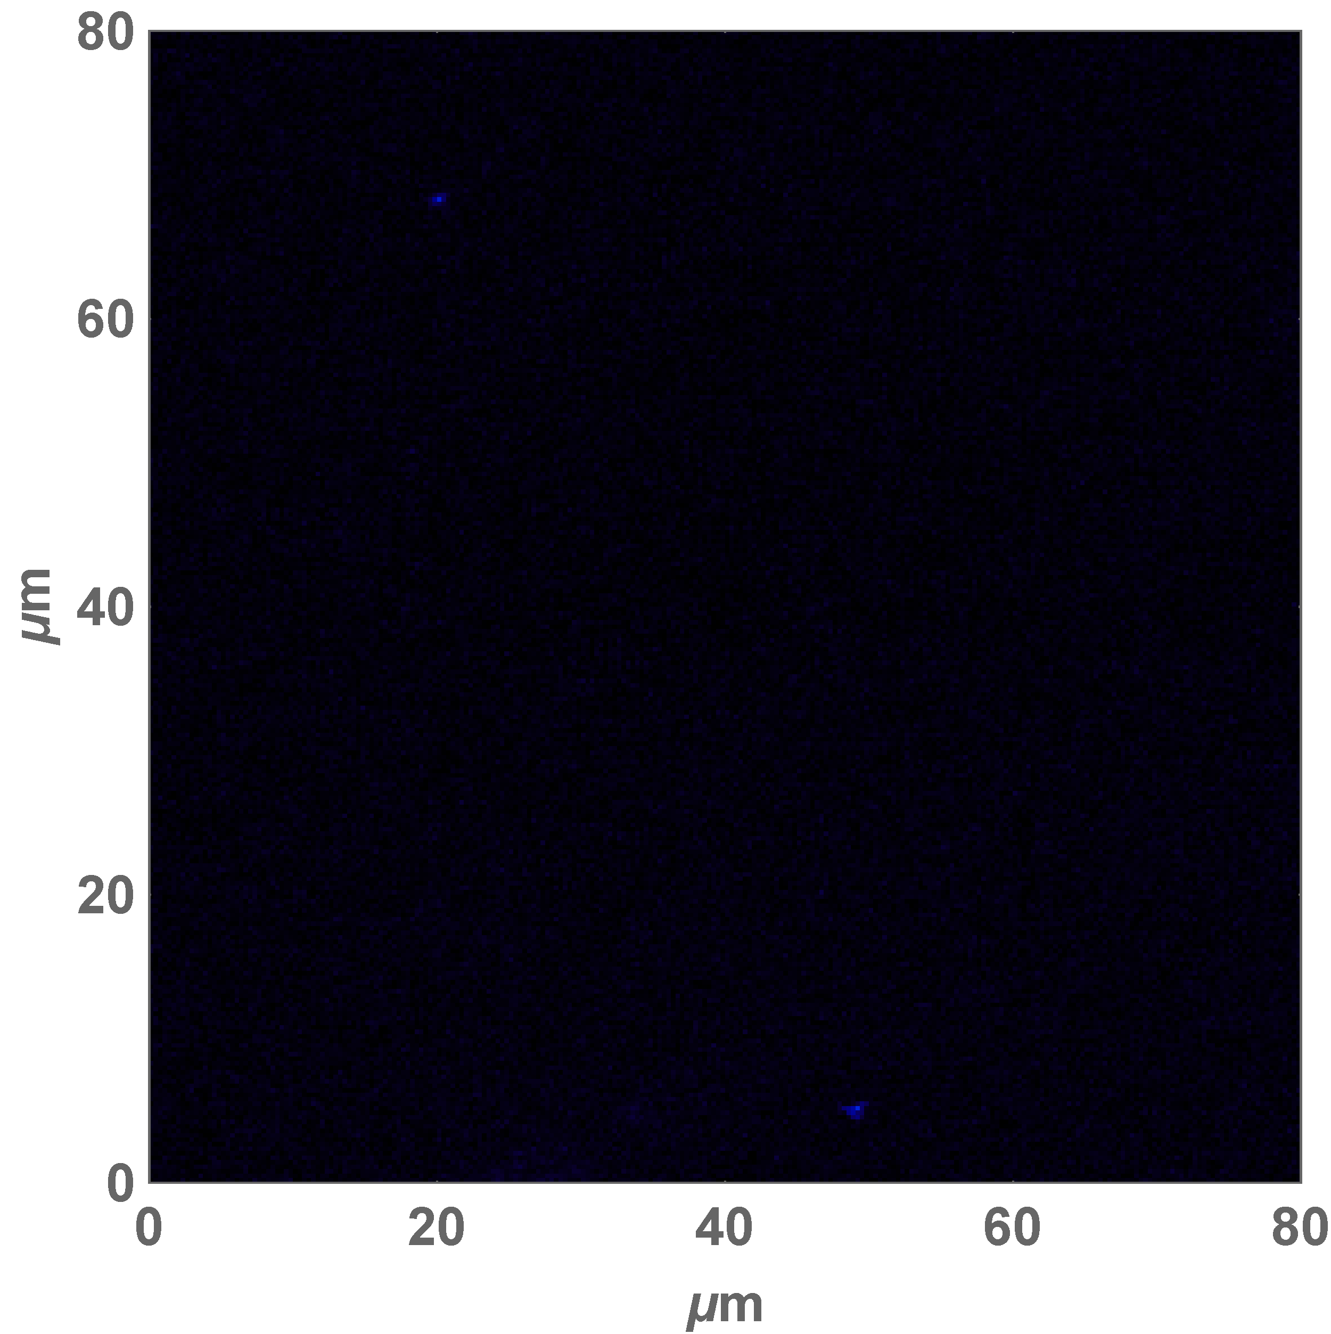

B

(ii)

(iii)

**Figure S2. DNA binding to SSB inhibits phase separation.**

**(A)** Turbidity curves for SSB alone (4 µM, green) and for preformed SSB:dT35/70 =1:1 complexes (15 µM, magenta) obtained upon decreasing temperature in the range from 35oC to 3oC with a rate of 0.2 oC/min (buffer T, 0.1M KGlu). **(B)** Microscopic images of 4 µM solution of SSB (+ 20 nM of SSB labeled with Alexa 555; exc: 485 nm, em: 642±40 nm) obtained for (i)- SSB alone; (ii)- and upon addition of 2 µM dT35, and (iii)- addition of 4 µM dT35 (buffer T, 0.1M KGlu). The images were obtained at room temperature, ~23oC, in the region of intermediate turbidity (as indicated by the arrow in panel A).



**10 mM KGlu**

A

B

C

**10 mM KCl**

D

F

E

**200 mM KCl**

**500 mM KCl**

**200 mM KGlu**

**500 mM KGlu**



**Figure S3. Salt concentration and type regulate non nearest-neighbor (NNN) cooperative binding of wtSSB to M13-ssDNA** (modified from Fig. 3 of Kozlov et al[1]).Highly cooperative SSB-ssDNA binding persists in high [KGlu], but is diminished in high [KCl]. Representative sedimentation velocity c(s) distributions converted to 20 °C, water conditions for wtSSB-M13ssDNA complexes at protein to DNA ratio: R65 = 0.56 (blue), where R65 = [SSBtetr,tot] × 65/[M13ssDNAnts,tot]. M13ssDNA alone (25 μM nts) is shown in green. (A) – 10 mM KCl, (B) – 10 mM KGlu, (C) – 0.20 M KCl, (D) – 0.20 M KGlu, (E) – 0.50 M KCl and (F) – 0.50 M KGlu.

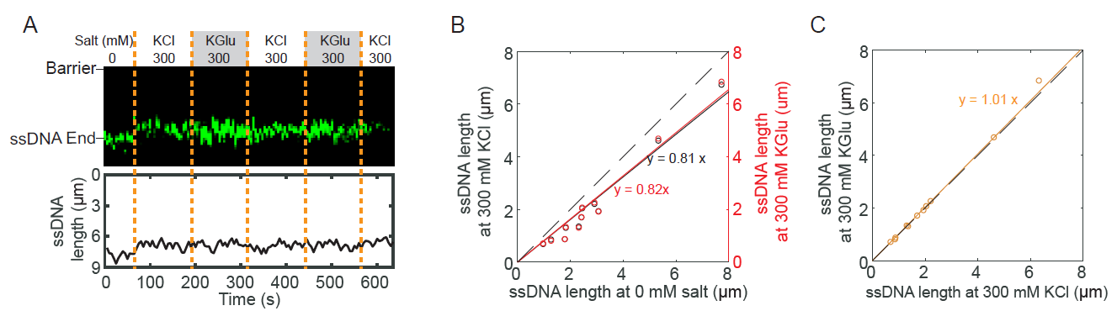

**Figure S4. Change in salt concentration and type have little or no effect on the length of unbound ssDNA.**

(**A**) Representative kymograph (top) and single-particle tracking (bottom) showing the effects of salt on ssDNA end (green). Dashed orange lines denote when the buffer was switched. (**B**) Correlation between ssDNA lengths at 0 and 300 mM KCl (black), and at 0 and 300 mM KGlu (red). The solid lines are a linear fit to the data (N = 11 molecules). The dashed line represents a slope of 1. (**C**) Correlation between ssDNA lengths at 300 mM KCl and 300 mM KGlu (orange).

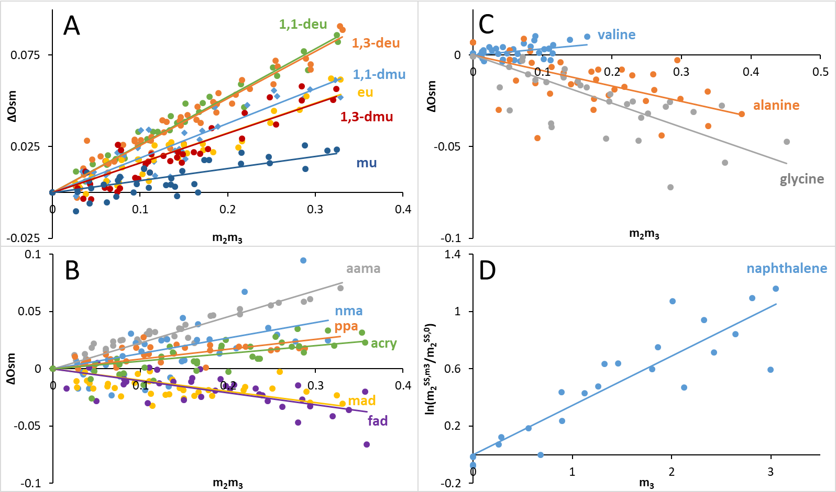

**Figure S5**. Determinations of μ23 for Interactions of KCl with Protein Model Compounds by Osmometry and Solubility Assays. In Panels A – C, osmolality differences ΔOsm (defined in Eq. 1) at 23 oC are plotted as a function of the product of molalities of KCl (m3) and the model compound (m2) according to Eq. 2 and μ23 is obtained from the slope. In Panel D, the logarithm of the normalized solubility of naphthalene (m2SS/m2SS,0) at 25 oC is plotted vs the molal concentration of KCl (m3) according to Eq 3 and μ23 is obtained from the slope.

**Figure S6**. Predicted vs Observed μ23 Values for KCl. Values are listed in table S1. The dashed line represents agreement between predicted and observed μ23 values.

**Table S1.** Values of µ23 at 23 °C for KCl- model compound interactions and comparison with KGlu [2]. Three compounds with primarily amide ASA are listed first. Other compounds are listed in order from the most favorable to the most unfavorable interaction with KCl. Units of µ23 are cal mol-1 m-1.

|  |  |  |  |  |
| --- | --- | --- | --- | --- |
|  | **KCl** | | **KGlu** | |
| **Model Compound** | **Observed** | **Predicted** | **Observed** | **Predicted** |
| formamide | -61 ± 5 | -40 ± 6 | * | * |
| malonamide | -57 ± 5 | -31 ± 10 | 48 ± 2 | 77 ± 13 |
| urea | -28 ± 3 | -39 ± 10 | 31 ± 2 | -6 ± 11 |
| glycine | -77 ± 6 | -72 ± 10 | -50 ± 4 | -38 ± 8 |
| alanine | -49 ± 6 | -38 ± 10 | 29 ± 2 | 24 ± 8 |
| valine | 20 ± 4 | 16 ± 11 | 117 ± 5 | 109 ± 8 |
| proline | 25 ± 4 | -3 ± 11 | 161 ± 4 | 160 ± 7 |
| glycine betaine | 28 ± 1 | 45 ± 11 | 292 ± 4 | 294 ± 7 |
| methylurea | 39 ± 3 | 40 ± 7 | 111 ± 6 | 121 ± 8 |
| acrylamide | 40 ± 5 | 21 ± 5 | * | * |
| propionamide | 51 ± 5 | 63 ± 7 | 174 ± 6 | 176 ± 7 |
| methylacetamide | 80 ± 12 | 97 ± 7 | * | * |
| 1,3-dmu | 95 ± 4 | 119 ± 8 | 249 ± 5 | 248 ± 6 |
| ethylurea | 96 ± 3 | 69 ± 8 | * | * |
| 1,1-dmu | 111 ± 4 | 80 ± 7 | * | * |
| aama | 134 ± 4 | 116 ± 11 | 406 ± 6 | 390 ± 11 |
| 1,3-deu | 151 ± 3 | 177 ± 10 | 348 ± 7 | 350 ± 7 |
| 1,1-deu | 154 ± 2 | 134 ± 9 | 284 ± 4 | 292 ± 8 |
| benzene | * | * | 291 ± 11 | 265 ± 8 |
| naphthalene | 203 ± 12 | 207 ± 4 | 322 ± 14 | 342 ± 10 |
|  |  |  |  |  |

*not determined

**Table S2.** Intrinsic Strengths (α-Values) for Interactions of KCl with

O, N, C Unified Atoms of Protein Model Compounds

|  |  |  |
| --- | --- | --- |
| Unified Atom (Type,  Hybridization) | KCl α-value  (cal mol-1 m-1A-2) | KGlu α-valuea  (cal mol-1 m-1A-2) |
| Amide sp2O | -1.85 ± 0.05 | 0.76 ± 0.15 |
| Amide sp2N | 0.34 ± 0.07 | -0.39 ± 0.07 |
| Carboxylate sp2O | -1.84 ± 0.11 | 0.37 ± 0.07 |
| Cationic sp2N,sp3N | 0.55 ± 0.04 | -1.87 ± 0.07 |
| Aliphatic sp3C | 0.86 ± 0.04 | 1.34 ± 0.02 |
| Aromatic sp2C | 0.76 ± 0.02 | 1.25 ± 0.04 |

a [2]

**Table S3.** Contributions to Effects of KGlu and KCl on TPS From Interactions of these Salts with G Backbone and Q,N Side Chain Amide Groups

|  |  |  |
| --- | --- | --- |
| Amide Residue  Contribution to PS | G backbone | Q, N side chain |
| Amide O ASA (A2) | 28 A2 | 45 A2 |
| Amide N ASA (A2) | 17 A2 | 53 A2 |
| KCl-Amide O Contribution to PS | +52 cal mol-1 m-1 | +83 cal mol-1 m-1 |
| KCl-Amide N Contribution to PS | -6 cal mol-1 m-1 | -18 cal mol-1 m-1 |
| Net KCl-Amide O,N Contribution to PS | +46 cal mol-1 m-1 | +65 cal mol-1 m-1 |
| K-Glu Amide O Contribution to PS | -21 cal mol-1 m-1 | -34 cal mol-1 m-1 |
| KGlu-Amide N Contribution to PS | +7 cal mol-1 m-1 | +21 cal mol-1 m-1 |
| Net KGlu-Amide O,N Contribution to PS | -14 cal mol-1 m-1 | -13 cal mol-1 m-1 |
| Total Possible KCl Contribution per SSB tetramera | + 3.1 kcal mol-1 m-1 | +3.6 kcal mol-1 m-1 |
| Total Possible KGlu Contribution per SSB tetramera | -1.0 kcal mol-1 m-1 | -0.7 kcal mol-1 m-1 |

a From salt interactions with 17x4 G amides and 14x4 Q,N side-chain amides.

**References**

[1] Kozlov AG, Shinn MK, Weiland EA, Lohman TM. Glutamate promotes SSB protein-protein Interactions via intrinsically disordered regions. J Mol Biol. 2017;429:2790-801.

[2] Cheng X, Guinn EJ, Buechel E, Wong R, Sengupta R, Shkel IA, et al. Basis of Protein Stabilization by K Glutamate: Unfavorable Interactions with Carbon, Oxygen Groups. Biophys J. 2016;111:1854-65.